Quick start guide SMALLLABS_JH_GUI

Last updated 2019-08-16, Koen Martens

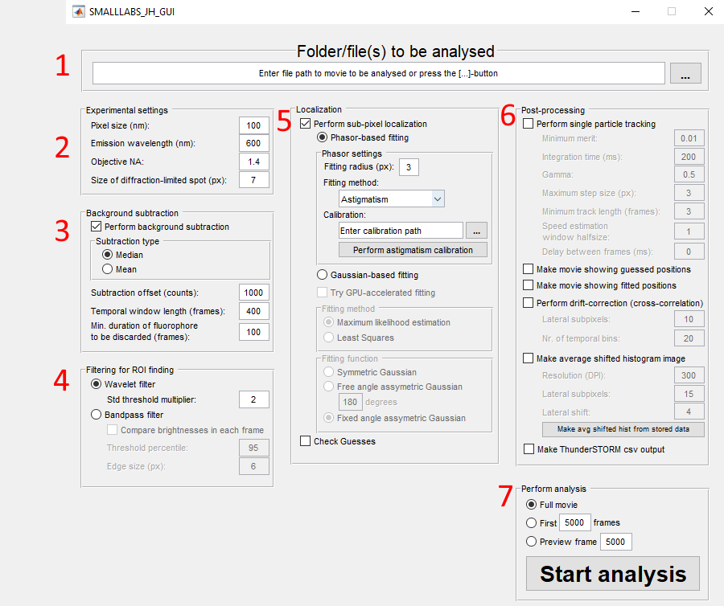

# Step 1: Choose movie

Select a .tiff file ([…]-button) or enter the path the movie. You can also choose a .mat file if the movie has been converted by SMALL-LABS before.

# Step 2: Choose experimental settings

Here, some experimental settings can be edited. Note that these are mainly used to calculate the size of the diffraction limited spot (lowest input box). You can also enter a diffraction-limited spot by hand. The only other use for these values is that the pixel size is used to make a correct scale-bar in image generation (step 6)

# Step 3: Choose background subtraction

Check the checkbox to perform BG subtraction or not. If checked, it will do the default SMALL-LABS BG subtraction, removing the median (or mean) noise from pixels based on the temporal points where no emitter is present. The temporal window length is the window of temporal points; min. duration of fluorophore to be discarded is the length an ‘immobile particle’ should have before it’s discarded. The ‘Subtraction offset’ value only ensures that all values are > 0 when subtraction is done, so this can be set arbitrarily high without affecting results.

# Step 4: Choose ROI finding options

Choose the ROI finding options here. Default values are normally OK-ish. There is currently no way to preview the exact filter. You can perform analysis on ‘preview frame’ (step 7) mode to test out filtering options.

# Step 5: Choose sub-pixel localization

Check the top-most box to perform sub-pixel localization. Then you have a choice between phasor-fitting or Gaussian-fitting. For Phasor-fitting, you have to choose a ROI radius (normally, for 2D or astigmatism, 2-3 pixels is good). For Saddle-point and Tetra-pod, you have to choose 2 ROI radii, where the first value should be small (2-3 pixels; around the size of a single lobe), and the second value should be large (around half the size between the maximum separation of individual lobes – normally ~ 10-15 px). For DH, this value should be ~3-4 pixels for optimal results.

In case of 3D methods, a calibration should be performed and pointed to. By pressing the ‘Perform … calibration’, the correction calibration procedure starts, and will be saved as a .mat file. This .mat file should be entered when performing analysis.

For Gaussian-based fitting, there are some self-explanatory options for fitting methods and functions.

# Step 6: Choose post-processing options

Post-processing such as tracking, making movies with guessed/fitted positions, 2D/3D drift-correction, making avg shifted histogram image, and making a ThunderSTORM-like CSV output can be enabled, disabled, and changed here. The default values are normally acceptable.

# Step 7: Perform analysis

Pressing the ‘Start analysis’ will perform the analysis with the chosen settings. If ‘full movie’ is selected, the whole movie will be analysed, while ‘First … frames’ will only analyse those first frames, and ‘preview frame …’ will show output of a single frame. Please note that some post-processing options are not done if the preview option is done (such as drift-correction, making avg shifted histogram, etc).